# Diabetes Classification Results using LogisticRegression

## Classification Report:

precision recall f1-score support  
  
 0 0.71 0.78 0.74 153  
 1 0.74 0.67 0.70 147  
  
 accuracy 0.72 300  
 macro avg 0.73 0.72 0.72 300  
weighted avg 0.73 0.72 0.72 300

## ROC AUC Score:

ROC AUC Score (LogisticRegression): 0.8152594371081766

## ROC Curve:

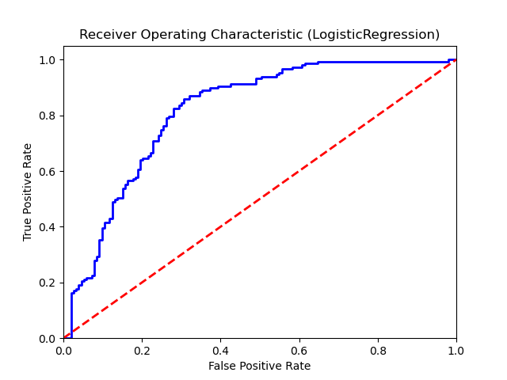

## Confusion Matrix:

True Negatives: 119

False Positives: 34

False Negatives: 49

True Positives: 98

## Confusion Matrix Plot:

